FEDERAL THEATRE PROJECT (1935-1939)

The Federal Theatre Project was a government-subsidized program established in 1935 by President Franklin D. Roosevelt to provide jobs for theatre artists during the Great Depression in the United States. Along with similar programs in Art, Music, Dance, and Writing, the project was designed to produce professional theatre throughout the country and eventually established companies in thirty-one American states. While the fare of the program was broad, including circuses, vaudeville, musicals, and children’s theatre, its offerings were largely progressive, which led to conflicts with Congressional Republicans who viewed the program as propaganda for New Deal politics. Eventually, charges of communism led to an investigation by the House Committee on Un-American Activities and the budgetary elimination of Federal Theatre in 1939.

As a part of the Works Progress Administration (WPA), Federal Theatre was supervised by Harry Hopkins and administered by Hallie Flanagan Davis, who had been a classmate of Hopkins at Grinnell College and who had established a very successful experimental theatre at Vassar College. Flanagan insisted that the program be ‘free, adult and uncensored’ (Arena, 28), and that its theatres reflect the entirety of the American people, as well as the serious economic and political threats that confronted them. She undertook the establishment, for example, of several Negro theatres (in Harlem, Newark, Chicago, and Seattle) that produced plays about black experience in the United States during a decade when race riots and public lynchings were not uncommon. These theatres were controversial and did not prosper in the Deep South, but they contributed to the body of work popularized during the Harlem Renaissance and encouraged dozens of African American writers, designers, composers, and performers to pursue careers in the theatre. One of Federal Theatre Project’s most celebrated productions was a ‘voodoo Macbeth’ (1936) that was directed by Orson Welles and set in Haiti with an all-black cast.

While the predominant style of Federal Theatre was traditional and frequently realistic, an important exception was the Living Newspaper unit, which produced socially relevant plays on current political topics such as subsidized housing (One-Third of a Nation, 1938), socialized medicine (Spirochete, 1938), and public ownership of utilities (Power, 1937). These productions were influenced by Russian and German models and experimented with both epic and expressionistic devices. A typical Living Newspaper production utilized a narrator, short scenes with characters that represented ideas and attitudes rather than psychological complexity, and direct address to the audience. Injunction Granted (1936), for example, was clearly inspired by the Russian director Nikolai Ohklopkov. Its open stage with circles of platforms and a dozen designated playing areas reflected staging and design concepts that director Joseph Losey had seen in Vsevolod Meyerhold’s and Ohklopkov’s theatres in Moscow, and its clown figure, who comments ironically on the action of the play, combines with a loudspeaker voice to break through the traditional fourth wall. Unfortunately, the play’s enthusiastic endorsement of the Congress of Industrial Organizations (CIO) led to charges of communism that not only forced an early closing of Injunction Granted but ultimately led to the termination of the entire Federal Theatre Project. During its brief tenure, however, the project staged several remarkable productions, including The Cradle Will Rock (1937), It Can’t Happen Here (1936), and Prologue to Glory (1938), and introduced many artists, including Orson Welles, John Houseman, and Rose McClendon, who made significant contributions to American theatre.

List of Works

De Rohan, Pierre, ed. (1938) Federal Theatre Plays, New York: Random House.

References and Further Reading

Cobb, Gerry. (1990) ‘Injunction Granted in Its Times: a Living Newspaper Reappraised’, New Theatre Quarterly 6 (23): 279-296.

Flanagan, Hallie. (1940) Arena, New York: Duell, Sloan and Pearce.

Fraden, Rena. (1994) Blueprints for a Black Federal Theatre, 1935-1939, New York: Cambridge University Press.

Mathews, Jane. (1967) The Federal Theatre Project, Princeton: Princeton University Press.

“New Deal Programs: Selected Library of Congress Resources: Federal Theatre Project,” <http://www.loc.gov/rr/program/bib/newdeal/ftp.html>.
Osborne, Elizabeth A. (2011) Staging the People: Community and Identity in the Federal Theatre Project, New York: Palgrave Macmillan.

Witham, Barry B. (2003) The Federal Theatre Project: A Case Study, New York: Cambridge University Press.

Barry B. Witham, University of Washington

Recommended Illustrations
[Please use film footage plus two illustrations if possible]

Original footage of Orson Welles’s “voodoo Macbeth” (1936).
[Available at: http://www.filmpreservation.org/preserved-films/screening-room/voodoo-macbeth]
[Also available at: www.youtube.com/watch?v=Xa9Mjfr5foY]
[If it’s not possible to use this footage, please let us know as there are still photographs of this production that could be used instead, but it would be great to use the film footage, so please try for that.]

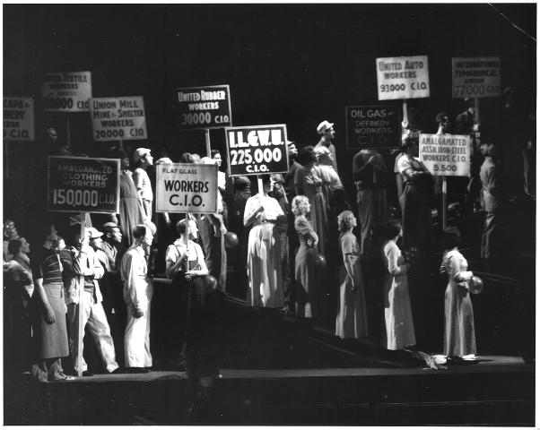

Injunction Granted, Living Newspaper, Federal Theatre Project, 1936.
[Reproduced in Lorraine Brown, “Federal Theatre: Melodrama, Social Protest, and Genius,” which is linked to the Library of Congress webpage listed above. The article is at http://memory.loc.gov/ammem/fedtp/ftbrwn00.html; the photo is at http://memory.loc.gov/ammem/fedtp/images/ftbrwn07.jpg]

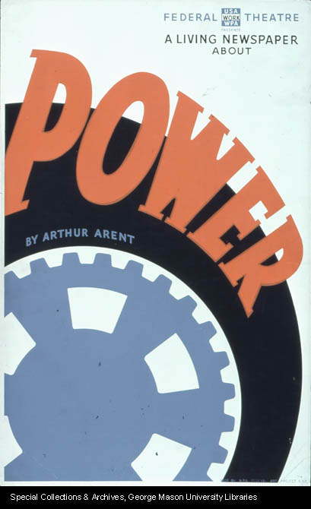

Poster for Power, Federal Theatre Project, 1937.
[Available at George Mason University Libraries: http://digilib.gmu.edu/dspace/handle/1920/4017]

